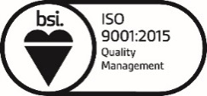
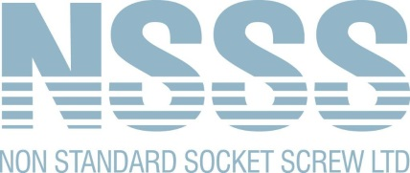
FM 25045
Sales: 0121 515 0121
Accounts: 0121 515 0100
www.nssocketscrews.com
sales@nssocketscews.com
January, 2023

Environmental Policy
Our relationship with the environment forms an essential part of our business ethos at Non-Standard Socket Screw Limited. We understand that a healthy environment not only benefits us but the broader community and future generations. With this in mind, we're making genuine strides to reduce our environmental footprint.
Management Structure
Our approach to the environment is systematic, aligning with the BS EN ISO 14001:2015 guidelines. This structure guides us in making steady improvements, from reducing pollutants to bettering our overall environmental performance.
Our Pledge
Here’s what we promise:
1. Regulations: We'll always meet UK legal and regulatory requirements. When possible, we'll do our best to go beyond.
2. Decision-making: Environmental considerations play a key role in our business choices.
3. Team Awareness: We are nurturing a company culture where every team member is aware of our environmental goals and is equipped with the knowledge to contribute positively.
4. Energy Use: We are keen on optimising our energy use to be more efficient.
5. Resource Mindfulness: The concepts of Reduce, Re-use, and Recycle are not just buzzwords for us; they inform our daily operations. We keep an eye out for fresh ways to implement these principles.
6. Waste Handling: We've partnered with licensed organizations to manage our waste, ensuring a minimal impact on the environment.
Shared Duty
Every department in Non-Standard Socket Screw Limited shares in the responsibility of this policy. We believe that with consistent effort, we can contribute quietly but effectively to a greener future.
Should you require any further information, please do not hesitate to contact me.

Mr Melvin White
Managing Director
Tel: 0121 515 0121
Email: MW@nssocketscrews.com

