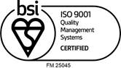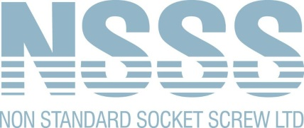
Sales: 0121 515 0121
Accounts: 0121 515 0100
www.nssocketscrews.com
sales@nssocketscews.com

October 2022
Anti-Bribery and Corruption Policy
Introduction
Our company is committed to conducting business in an ethical and honest manner and has a zero-tolerance policy towards bribery and corruption. This policy outlines our position on preventing and prohibiting bribery, and provides guidelines aimed at:
Complying with anti-bribery and corruption laws, rules, and regulations, not just within our locality, but any other country where we operate in.
Upholding the values of transparency, honesty, and ethical behaviour.
Providing guidance to our partners, suppliers, and customers about our policy.
Scope of the policy
This policy applies to all individuals working at all levels and grades, including senior managers, officers, directors, employees (whether permanent, fixed-term, or temporary), consultants, contractors, trainees, seconded staff, casual workers, volunteers, interns, agents, sponsors, or any other person associated with us.
Our company expects that all business partners, vendors, customers, and suppliers adhere to this policy as a part of our business agreement.
Policy statements
Bribery: Our company prohibits the offering, giving, solicitation, or the acceptance of any bribe, whether cash or other inducement to or from any person or company, wherever located in the world. We prohibit indirect contributions, payments or gifts made in any form, to or for the benefit of any public official, client, or agent.
Gifts and Hospitality: Our company allows for normal and appropriate hospitality. However, giving or receiving gifts is not allowed if it creates an improper advantage or is in violation of law. Gifts and hospitalities must be reasonable in value, appropriate, lawful, and approved by management. They must not be offered with the intention to influence a third party to obtain or retain business or a business advantage.

Donations: We only make charitable donations that are legal and ethical under local laws and practices. No donation must be offered or made without the prior approval of the senior management.
Record Keeping: Our company keeps detailed and accurate financial records, and we have appropriate internal controls in place to act as evidence for all payments made. We will declare and keep a written record of the amount and reason for hospitality or gifts accepted and given.
Responsibilities and enforcement
Everyone within the company must read, understand, and comply with this policy. It is the responsibility of all to prevent, detect, and report bribery. Any breach of this policy will be regarded as a serious matter by the company and is likely to result in disciplinary action.
We commit to investigate and respond firmly to any violations. This may include termination of employment, termination of business relationship, and reporting the matter to the relevant authorities.
Reporting
Any suspicions of bribery should be reported immediately to your supervisor, or through our confidential reporting hotline. We will ensure that individuals who refuse to accept or offer a bribe, or those who raise concerns, are not subjected to any form of retaliation.
Training
Training on this policy forms part of the induction process for all new employees. Employees will receive regular, relevant training on how to adhere to this policy, and will be asked annually to formally accept that they will comply with this policy.
Non Standard Socket Screw Limited is committed to conducting its business with honesty and integrity and expects all staff to maintain high standards. Any perceived breach of this policy will be taken seriously and may lead to disciplinary action.
This policy will be regularly reviewed and updated as necessary. The management team endorses this policy and is fully committed to its implementation.

Melvin White
Managing Director
October 2022

